API Details

Endpoint : api/CC/Validate

Ex: https://localhost:7163/api/CC/Validate

Parameter : credit card number (single value)

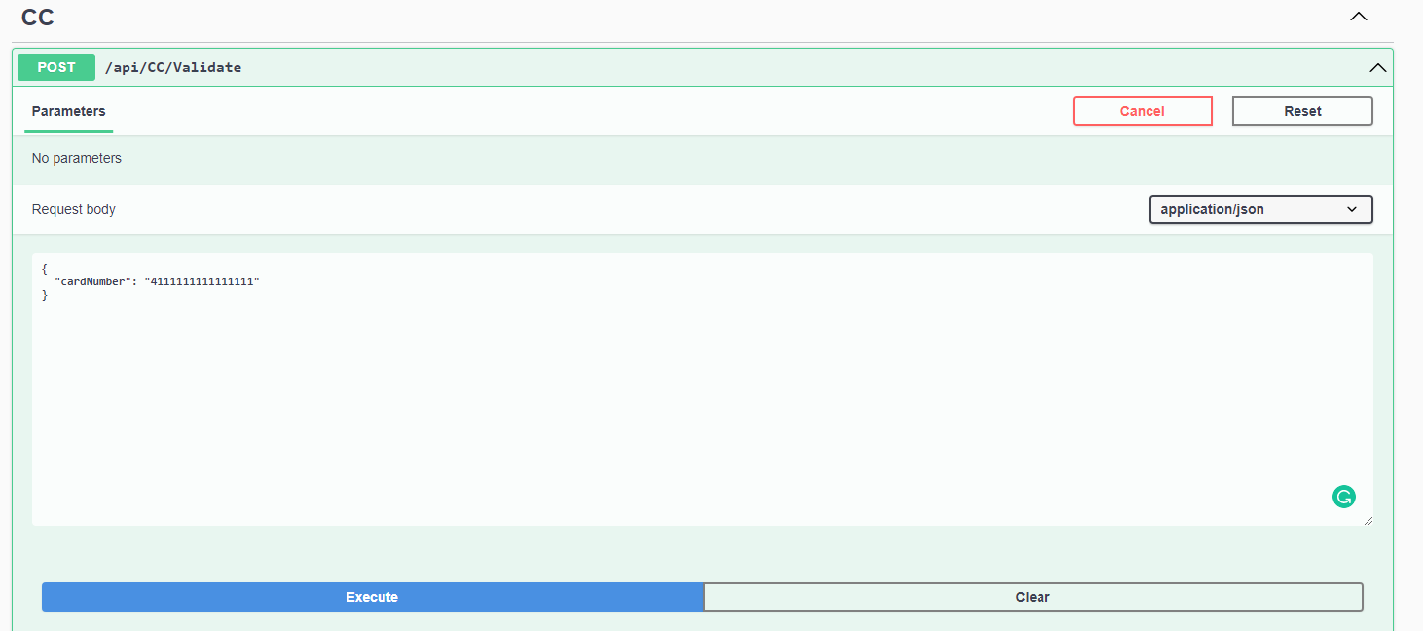Sample Request

Sample Response

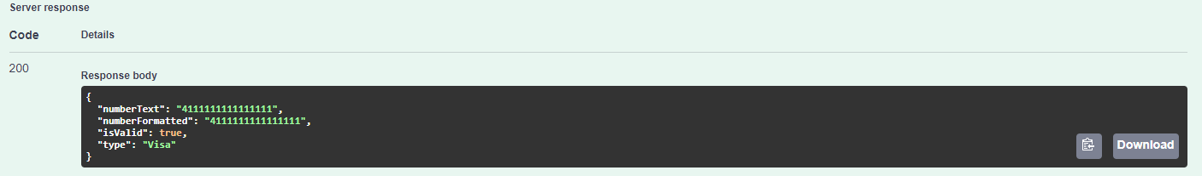

Swagger

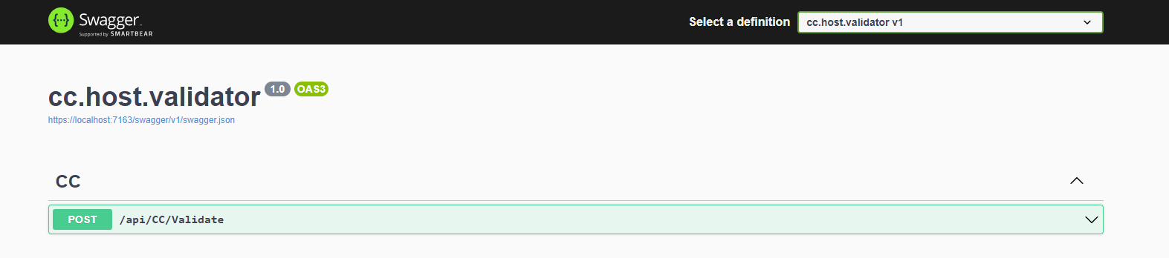

Frontend

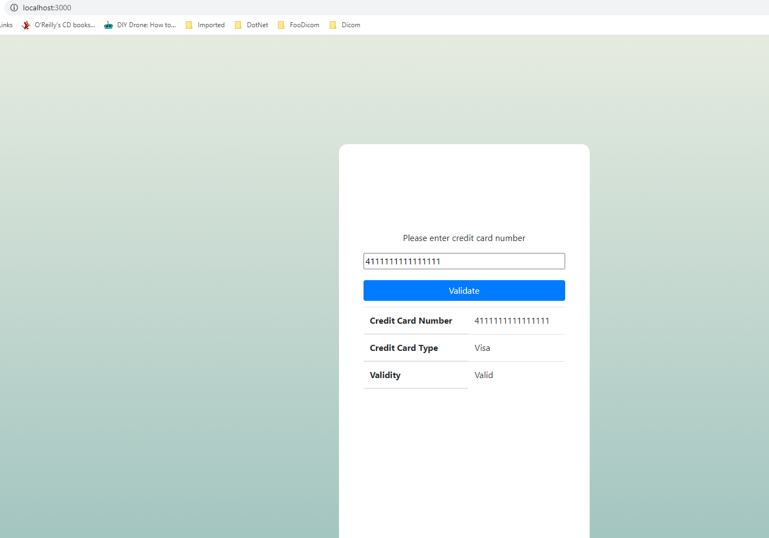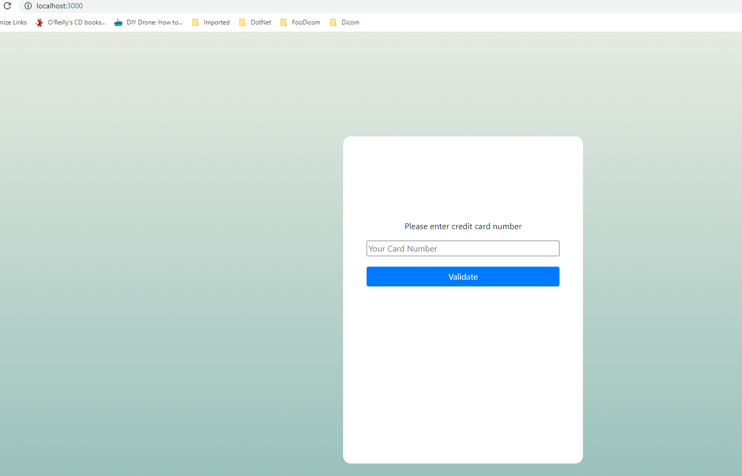

Unit test

